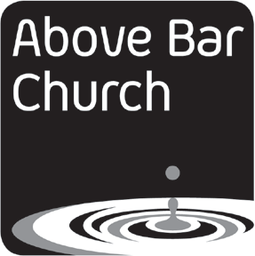

Your Name: Relationship to child: Name of Child:

Photograph of child/ young person (for the purposes of identification in any photographs which will subsequently be deleted from digital media once identi- fied.)

Photography Opt-out Form

I do not consent to Above Bar Church taking, storing, or using photographs or video recordings of my child.
I understand that they may be photographed or filmed inadvertently when in a group context. These photographs and videos must be deleted, cropped or pixelated before long- term storage so that my child can no longer be identified in any stored or published material.
I have provided, or permitted to be taken, a photograph of my child for the sole purpose of identifying them in, and eliminating them from, photographs and videos which are taken at an event.
My reason for withholding consent for photographs and videos is:
(This is optional, but it may help inform our future policy regarding images and publicity.)

Signature of parent/guardian: Date:

How we use photographs and video
Above Bar Church is committed to safe practice when dealing with images of children. Images are used:
- to help children have good memories of church activities
- in videos or slideshows for use in church events (e.g. Sunday services)
- for publicity purposes, including on the church website and related social media
No names or any other personal information, which could enable identification of a child, are used. All images are securely stored and password-protected. The use of images is subject to the Above Bar Church Photography Policy, Safeguarding Policy, relevant Individual Group Policies, and Data Protection Policy, which provide safeguards against misuse of the images. It is not possible to opt out of only some uses of photographs and video because of the practical difficulties this causes for those using material in church publicity contexts.

Privacy
Above Bar Church will store the details on this form, subject to the legal requirements of the Data Protection Act (1998). Above Bar Church will maintain the confidentiality of this information, and will store it securely on the church premises.

Above Bar Church is a charitable company limited by guarantee. Registered in England and Wales, registration no 6959469. Charity registration no: 1131075. Registered office Above Bar Street Southampton SO14 7FE
Opt-out form v.2 Sept. 2015

